# *Online Complaint Reistration and Management System*

**Project Title:**  
*Online Complaint Registration and Management System (OCRMS) for Naan Mudallvan*

*Introduction:-*

*The **Online Complaint Registration and Management System** (OCRMS) is a web-based application designed to provide an efficient platform for citizens, employees, or customers to register complaints and track their resolutions in real time. This system aims to streamline the process of managing complaints, improving transparency, reducing delays, and enhancing user satisfaction.*

*The system can be used in various domains like government services, corporate customer support, or organizational grievance handling. The goal of the OCRMS is to ensure that complaints are recorded, tracked, and resolved in an organized manner, offering a seamless user experience.*

**Project Overview:**  
The **Online Complaint Registration and Management System** aims to provide a user-friendly, efficient, and transparent platform for managing complaints from the customers of **Naan Mudallvan**. This system will enable customers to register complaints, track their status, and resolve issues quickly, improving customer satisfaction and service delivery.

**Key Features of the System:**

1. **Complaint Registration:**
   * Allows customers to submit complaints online via a web interface.
   * Includes fields for complaint type, description, and urgency level.
   * Customers can also upload supporting documents or images related to their complaint.

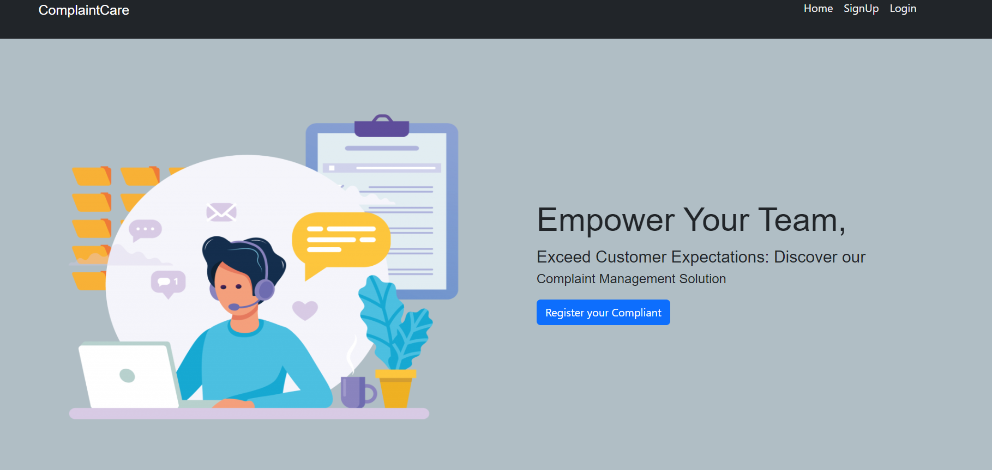

1. **Sign Up page:**

* Users can create an account by entering basic details like name, email, and password.
* A confirmation email is sent for account verification.
* Password strength requirements ensure secure account creation.
* Users can set up security questions for account recovery.

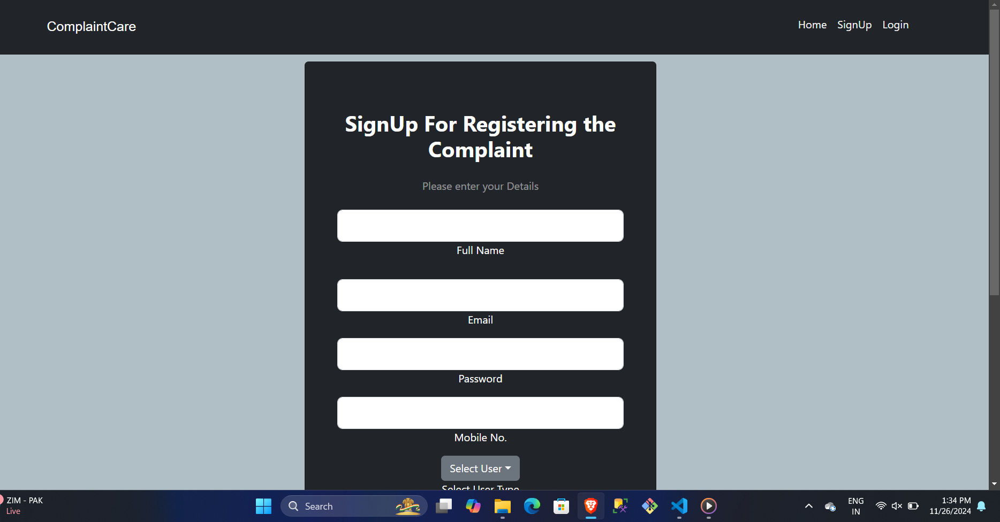

1. **Complaint Tracking:**
   * Customers can view the status of their complaints in real-time.
   * Automatic email or SMS notifications for status updates.
   * Clear display of complaint ID, current status (pending, in progress, resolved), and comments from customer support teams.

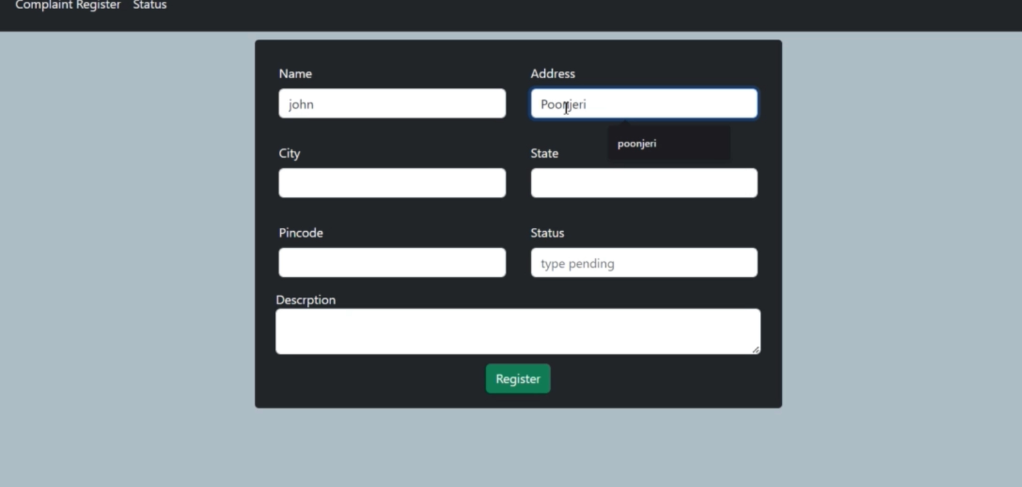

1. **Complaint Categorization:**
   * Complaints can be categorized into various types, such as quality issues, service issues, product delivery issues, etc.
   * Custom categories may be added by system administrators to adapt to changing needs.

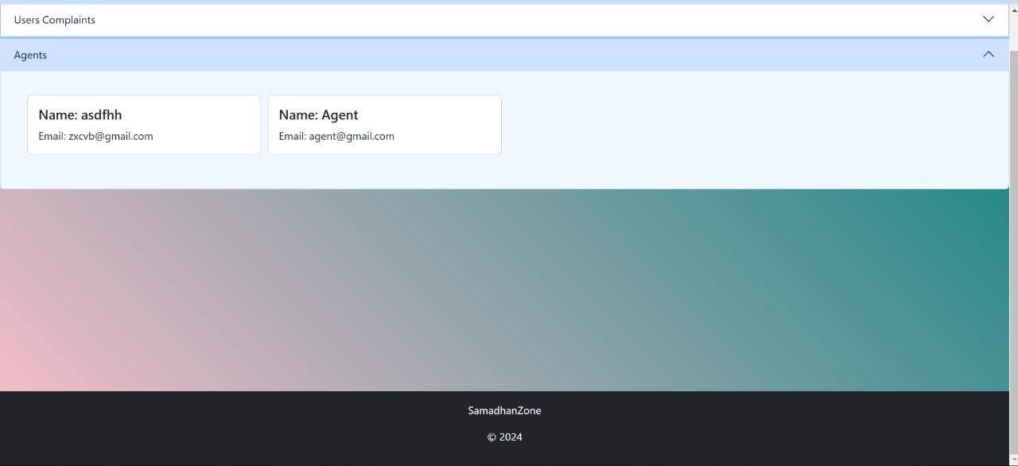

1. **Admin Dashboard:**
   * Admins can view and manage all complaints in the system.
   * Admins can assign complaints to specific teams or individuals for resolution.
   * Admins can track resolution times, view reports, and monitor complaint trends.

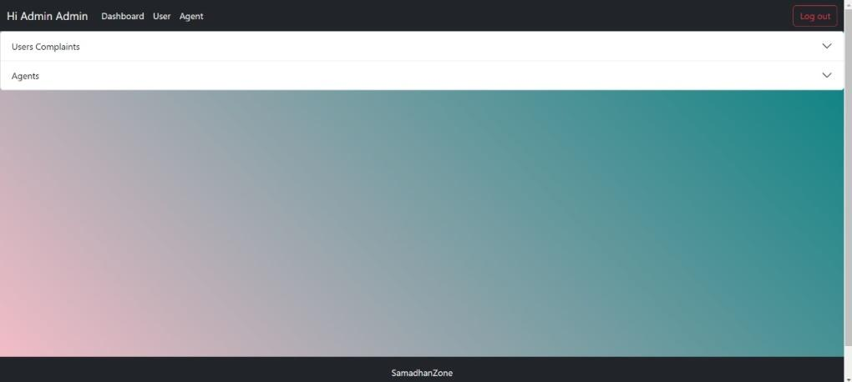

1. **Search and Filter:**
   * Advanced search and filtering options to help both customers and admins find relevant complaints quickly by date, category, status, etc.
   * Includes sorting options for prioritizing complaints based on urgency, date, and other parameters.

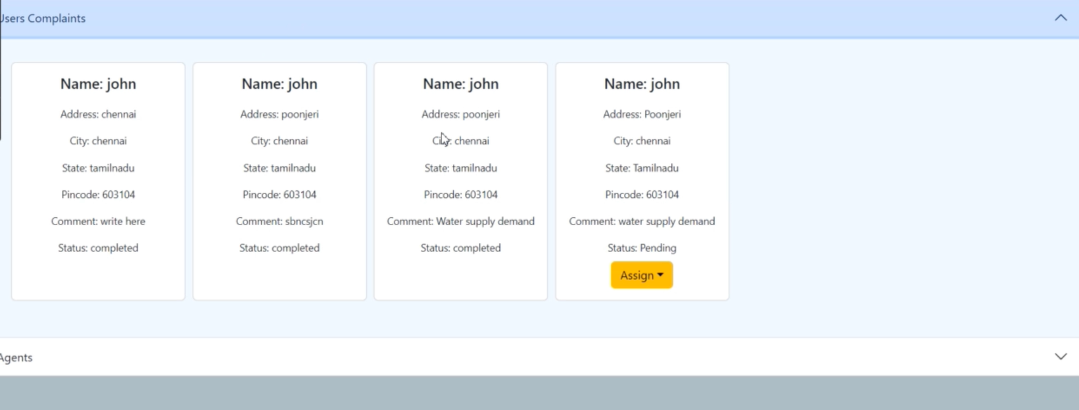

1. **Customer Interaction:**
   * Provides a messaging system for customers to interact with support agents.
   * Allows customers to request updates or provide additional information as needed.

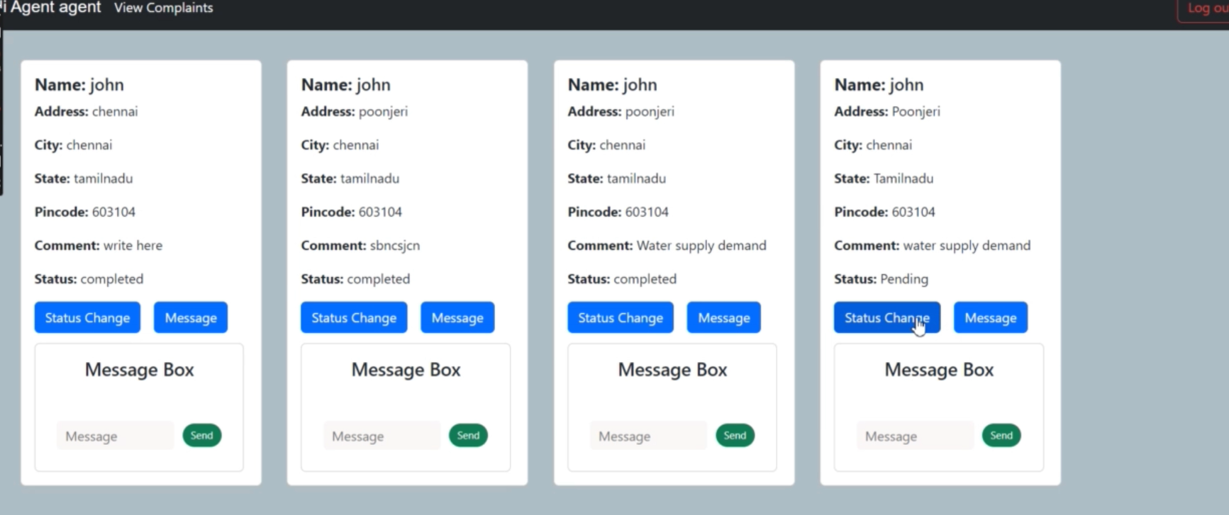

1. ***submit complaints***

* ***Complaints are submitted via an easy-to-use online form.***
* ***Each submission receives a unique tracking number.***
* ***Complaints are automatically assigned to the relevant team for resolution***.

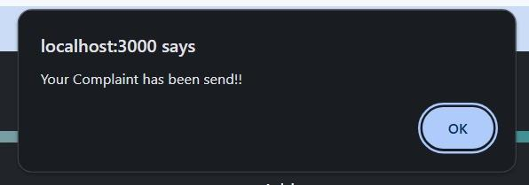

1. **MongoDB Backend:**
   * All complaint data, including user information, complaint details, and interaction logs, will be stored in a MongoDB database.
   * MongoDB’s flexible schema allows for easy scalability and adaptation as the business grows.
2. **Data Security:**
   * Use of encryption and secure authentication methods to protect user data.
   * Ensuring that the complaint details and personal information are kept private and secure.

**Technologies Used:**

* **Frontend:** HTML, CSS, JavaScript (React.js or Angular for dynamic user interfaces)
* **Backend:** Node.js with Express.js
* **Database:** MongoDB (NoSQL database, perfect for storing dynamic and unstructured complaint data)
* **Authentication:** JWT (JSON Web Tokens) for user authentication
* **Notifications:** Email (via services like SendGrid) or SMS (via Twilio API)

**Scope and Benefits:**

1. **Improved Customer Experience:**  
   The online portal allows customers to register their complaints at their convenience, thus offering them a smooth, streamlined process without the need for physical visits or phone calls.
2. **Faster Issue Resolution:**  
   With a systematic tracking mechanism and clear categorization of complaints, response times will improve, leading to faster issue resolution.
3. **Transparency and Accountability:**  
   The system provides transparency to customers about their complaint’s status and the steps taken towards resolution. It also holds staff accountable for their work through easy-to-track progress indicators.
4. **Data-Driven Insights:**  
   Admins can generate reports and insights into complaint trends, recurring issues, and areas of improvement. This helps Naan Mudallvan refine its processes and enhance the quality of its products/services.
5. **Scalability:**  
   With MongoDB as the backend, the system is scalable to handle increased traffic and a growing number of complaints as the business expands.

**Project Phases:**

1. **Requirement Gathering & Planning:**  
   Identify the specific requirements of Naan Mudallvan, including user roles (customers, admins), key functionalities, and reporting needs.
2. **System Design:**  
   Design the architecture of the application, focusing on the MongoDB database schema, user interface, and overall workflow.
3. **Development:**  
   Develop the front-end and back-end of the application, integrate MongoDB for data storage, and implement complaint tracking functionalities.
4. **Testing:**  
   Perform thorough testing of the system for usability, functionality, security, and performance. Fix bugs and refine the user experience.
5. **Deployment & Maintenance:**  
   Deploy the system on a cloud platform (e.g., AWS or Heroku) and provide ongoing maintenance and support for the system.

***Scenario-Based case study:-***

#### 1. **Stakeholders**

* **Users (Customers/Citizens)**: The primary individuals submitting complaints.
* **Support Team/Complaint Handlers**: The team responsible for processing and resolving complaints.
* **Admin**: Oversees the system, manages users, and generates reports.
* **Managers**: Track complaints, assign tasks to team members, and oversee resolution.
* **Development Team**: The team responsible for designing, implementing, and maintaining the system.
* **Governments/Service Providers**: The entities that are responsible for addressing and resolving the complaints.

#### 2. **System Requirements**

* **User Authentication**: Users must be able to sign up, log in, and authenticate securely.
* **Complaint Registration**: A user-friendly form where users can input the details of their complaints, such as the category, description, severity, and preferred resolution.
* **Complaint Tracking**: A system that allows users to track the status of their complaints (e.g., open, in progress, resolved).
* **Notification System**: Alerts to users and staff when the complaint is received, assigned, or resolved.
* **Feedback and Rating**: After resolution, users can provide feedback or rate the handling of their complaint.
* **Admin and Manager Dashboards**: Provide insights into pending, resolved, or escalated complaints.
* **Analytics and Reporting**: Generate reports on complaints (by category, severity, region, etc.).
* **Security**: Strong security protocols to protect sensitive data, ensure user privacy, and prevent unauthorized access.

#### 3. **System Design**

##### Architecture

* **Frontend**: A web-based user interface (UI) that is responsive and accessible across devices. Built using HTML, CSS, JavaScript, and frameworks like React or Angular for dynamic content.
* **Backend**: A RESTful API built with technologies like Node.js, Java, or Python (Django/Flask) to handle requests, interact with the database, and manage logic.
* **Database**: A relational database management system (RDBMS) like MySQL or PostgreSQL to store user details, complaints, resolutions, feedback, and other related data.
* **Security Protocols**: HTTPS, data encryption (for sensitive data), user authentication (JWT tokens, OAuth), and role-based access control.

##### Modules

1. **Complaint Registration Module**
   * The user enters complaint details such as title, description, category (e.g., maintenance, billing issue, etc.), location, and contact info.
   * Attachments (e.g., images, documents) can be added to better illustrate the complaint.
   * An acknowledgment receipt is sent to the user with a unique complaint ID.
2. **Complaint Tracking and Management**
   * Users can check the status of their complaints.
   * Staff can update the status of complaints, assign to relevant departments, and add comments for tracking purposes.
   * Complaints are categorized and prioritized based on severity.
   * Notifications are sent for any status changes.
3. **Admin and Manager Dashboard**
   * Admins and Managers can view a comprehensive list of all complaints.
   * View detailed analytics, such as complaints by category, average resolution time, and user feedback scores.
   * Managers can assign complaints to appropriate personnel, escalate issues, and monitor progress.
4. **Notification System**
   * Automated notifications to users when their complaint is received, when it's being processed, and when it is resolved.
   * Alerts for staff when a complaint is escalated or requires attention.
5. **Feedback and Rating**
   * Once a complaint is resolved, the user is prompted to rate their experience.
   * Feedback can be quantitative (star ratings) and qualitative (comments).

#### 4. **Workflow**

* **Step 1: Complaint Submission**  
  The user submits a complaint by filling in a form on the website or mobile app. The complaint is categorized, and an acknowledgment receipt is sent to the user.
* **Step 2: Complaint Processing**  
  The complaint is received by the backend system, which assigns it to a support team based on predefined rules (e.g., severity, category, location). Notifications are sent to the relevant department.
* **Step 3: Complaint Resolution**  
  The support team works on resolving the issue. Progress updates are made in the system, and users are notified of changes. The user can track the progress through the portal.
* **Step 4: Feedback**  
  Once the complaint is resolved, the user receives a notification asking for feedback or rating. The user can submit their feedback about how the complaint was handled.
* **Step 5: Closure and Reporting**  
  After the feedback is received, the complaint is marked as resolved, and the system generates relevant reports for the administration or management team to analyze.

#### 5. **Challenges and Solutions**

1. **Scalability**: As the system grows and more complaints are registered, the database and server infrastructure must be scalable to handle increasing loads.  
   **Solution**: Use cloud infrastructure (e.g., AWS, Azure) with autoscaling capabilities and distributed database management.
2. **Data Privacy and Security**: Users' personal information needs to be secured.  
   **Solution**: Implement data encryption, secure login mechanisms, and regular security audits to safeguard sensitive information.
3. **User Engagement**: Ensuring users are engaged and motivated to provide feedback after complaint resolution.  
   **Solution**: Implement a user-friendly interface and incentivize feedback (e.g., badges, points, or public acknowledgment).
4. **Complaint Escalation**: Timely escalation of unresolved complaints is crucial.  
   **Solution**: Set up automated escalation rules based on time or severity, and send automated reminders to ensure timely resolutions.

#### 6. **Technology Stack**

* **Frontend**: HTML, CSS, JavaScript, React or Angular.
* **Backend**: Node.js with Express, Python (Flask/Django), or Java (Spring Boot).
* **Database**: PostgreSQL, MySQL.
* **Authentication**: JWT (JSON Web Tokens), OAuth.
* **Hosting/Deployment**: AWS, Google Cloud, or Azure.
* **Version Control**: Git (GitHub or GitLab).
* **Communication**: Email/SMS API (SendGrid, Twilio).

#### 7. **Outcome**

* **Improved User Satisfaction**: Users can easily file complaints and track progress, leading to higher satisfaction.
* **Efficiency in Handling Complaints**: The system helps organizations quickly identify and prioritize complaints, reducing resolution time.
* **Transparency**: The tracking and feedback mechanisms increase transparency and accountability in the complaint handling process.
* **Data-Driven Decisions**: Analytics and reporting provide insights to improve services and operations.

#### 8. **Future Enhancements**

* **Mobile Application**: Develop a mobile app for iOS and Android for easier access and notifications.
* **AI Integration**: Implement AI/ML for automated categorization, sentiment analysis on feedback, or predictive analytics on complaint volume.
* **Integration with other Services**: Integration with other government or service-provider systems for automatic complaint transfer or resolution updates.

***Technical Architecture***

### **Technical Architecture of the Online Complaint Registration and Management System Using HTML, CSS, JavaScript, and MongoDB**

In this case, we are building an **Online Complaint Registration and Management System** using **HTML**, **CSS**, **JavaScript (JS)** for the frontend and **MongoDB** for the backend database. We will also use **Node.js** and **Express.js** as the backend server to handle HTTP requests, interact with MongoDB, and serve the frontend.

The architecture of the system will follow a **3-tier architecture model**, where the **Frontend** is responsible for the user interface, the **Backend** handles the business logic and API, and **MongoDB** acts as the data layer.

### **Overview of the System Components**

1. **Frontend (Presentation Layer)**: The user interface developed using HTML, CSS, and JavaScript for client-side interactions.
2. **Backend (Application Layer)**: A server built using Node.js with Express.js, which handles the requests and interacts with MongoDB.
3. **Database Layer**: MongoDB stores the data such as users, complaints, feedback, etc.

### **Frontend (User Interface Layer)**

The **Frontend** will be responsible for user interactions, such as complaint submission, complaint tracking, and user feedback. The frontend will communicate with the backend through **AJAX** or **fetch API** to send and retrieve data from the backend.

#### Technologies:

* **HTML**: For creating the structure of the web pages.
* **CSS**: For styling the pages and making them visually appealing and responsive.
* **JavaScript (JS)**: For client-side scripting to handle user interactions (e.g., form submissions, AJAX requests).

#### Key Components:

1. **Complaint Registration Form**: A form where users can submit complaints with details like category, description, priority, and any attachments (images, documents).
2. **Complaint Tracking Dashboard**: A page that allows users to track the status of their complaint (open, in progress, resolved).
3. **User Authentication**: A simple authentication page where users can log in and register.
4. **Complaint Feedback and Rating**: Once the complaint is resolved, users can rate the resolution process.

***Conclusion:-***

***In conclusion, creating an Online Complaint Registration and Management System streamlines the process of logging, tracking, and resolving complaints efficiently. It provides users with a simple and secure platform for submitting their issues, while ensuring transparency and accountability through real-time updates and tracking. By automating complaint routing and resolution, the system enhances customer satisfaction, improves response times, and facilitates better reporting and analysis, ultimately leading to more effective problem-solving and service improvement.***